Java Exception Handling 1

import java.util.*;
public class Solution {
public static void main(String[] args) {
Scanner sc = new Scanner(System.in);
try {
int x = sc.nextInt();
int y = sc.nextInt();
System.out.println(x / y);
} catch (InputMismatchException e) {
System.out.println("java.util.InputMismatchException");
} catch (ArithmeticException e) {
System.out.println("java.lang.ArithmeticException: / by zero");
}
}
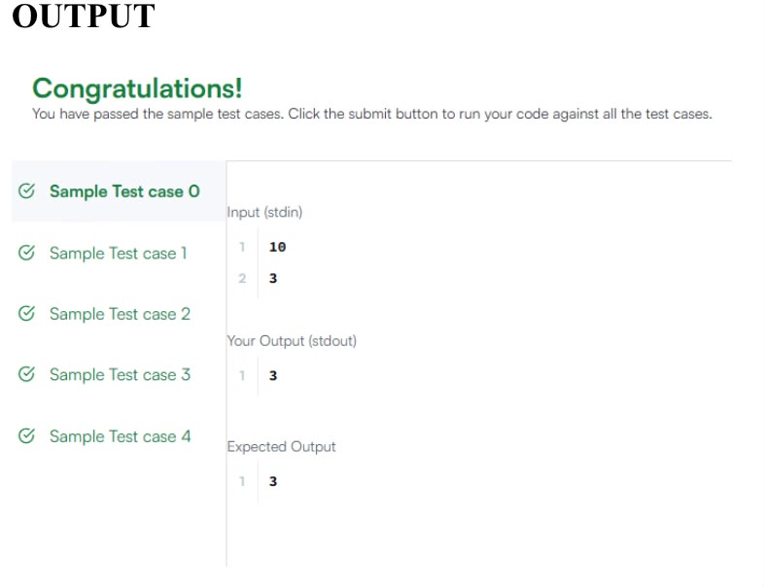

Java Exception Handling 2

class Geeks{
public static void main(String[] args) {

int n = 10;
int m = 0;

try {
int ans = n / m;
System.out.println("Answer: " + ans);
} catch (ArithmeticException e){
System.out.println("Error: Division by 0!");
}
}
}
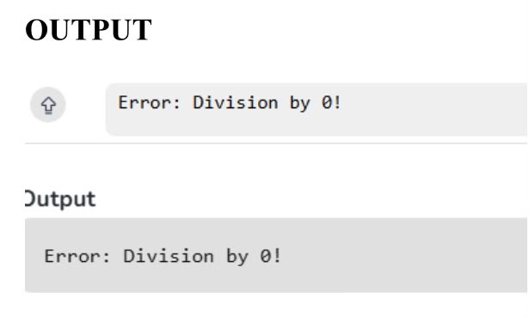

Java Exception Handling 3

import java.util.Scanner;
class MyCalculator {

long power(int n, int p) throws Exception {

if (n < 0 || p < 0) {
throw new Exception("n or p should not be negative.");
}

if (n == 0 && p == 0) {
throw new Exception("n and p should not be zero.");
}

return (long) Math.pow(n, p);
}
}

public class Solution {
public static final MyCalculator my_calculator = new MyCalculator();
public static final Scanner in = new Scanner(System.in);

public static void main(String[] args) {
while (in .hasNextInt()) {
int n = in .nextInt();
int p = in .nextInt();

try {
System.out.println(my_calculator.power(n, p));
} catch (Exception e) {
System.out.println(e);
}
}
}
}
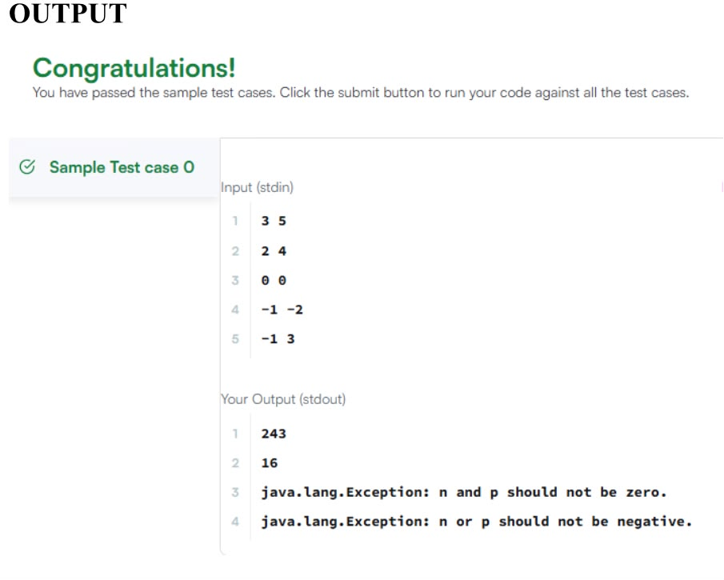
Java Factory pattern

import java.util.*;
import java.security.*;
interface Food {
public String getType();
}
class Pizza implements Food {
public String getType() {
return "Someone ordered a Fast Food!";
}
}

class Cake implements Food {

public String getType() {
return "Someone ordered a Dessert!";
}
}
class FoodFactory {
public Food getFood(String order) {

if (order.equals("pizza")) {
return new Pizza();
} else {
return new Cake();
}
}//End of getFood method

}//End of factory class

public class Solution {

public static void main(String args[]){
Do_Not_Terminate.forbidExit();

try{

Scanner sc=new Scanner(System.in);
//creating the factory
FoodFactory foodFactory = new FoodFactory();
//factory instantiates an object
Food food = foodFactory.getFood(sc.nextLine());
System.out.println("The factory returned "+food.getClass());
System.out.println(food.getType());
}
catch (Do_Not_Terminate.ExitTrappedException e) {
System.out.println("Unsuccessful Termination!!");
}
}
}
class Do_Not_Terminate {

public static class ExitTrappedException extends SecurityException {
private static final long serialVersionUID = 1L;
}
public static void forbidExit() {
final SecurityManager securityManager = new SecurityManager() {
@Override
public void checkPermission(Permission permission) {
if (permission.getName().contains("exitVM")) {
throw new ExitTrappedException();
}
}
};
System.setSecurityManager(securityManager);
}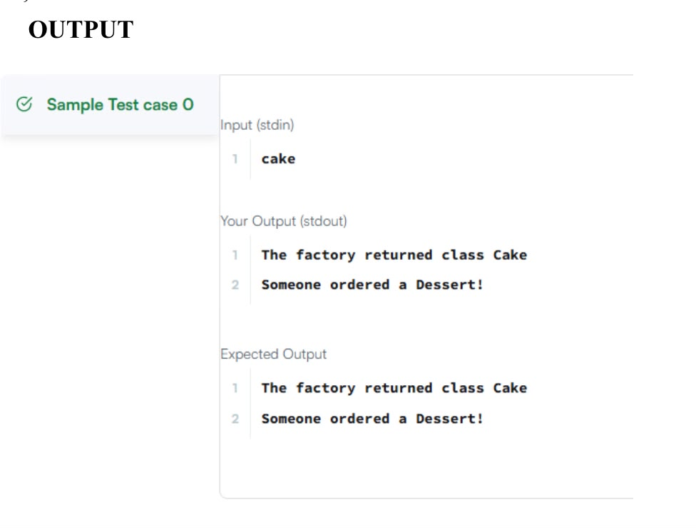
Java Hashset
import java.io.*;
import java.util.*;
import java.text.*;
import java.math.*;
import java.util.regex.*;

public class Solution {

public static void main(String[] args) {
Scanner s = new Scanner(System.in);
int t = s.nextInt();
String [] pair_left = new String[t];
String [] pair_right = new String[t];

for (int i = 0; i < t; i++) {
pair_left[i] = s.next();
pair_right[i] = s.next();
}
HashSet<String> set = new HashSet<String>();

for (int i = 0; i < t; i++) {
String pair = pair_left[i] + " " + pair_right[i];
set.add(pair);
System.out.println(set.size());
}
}
}
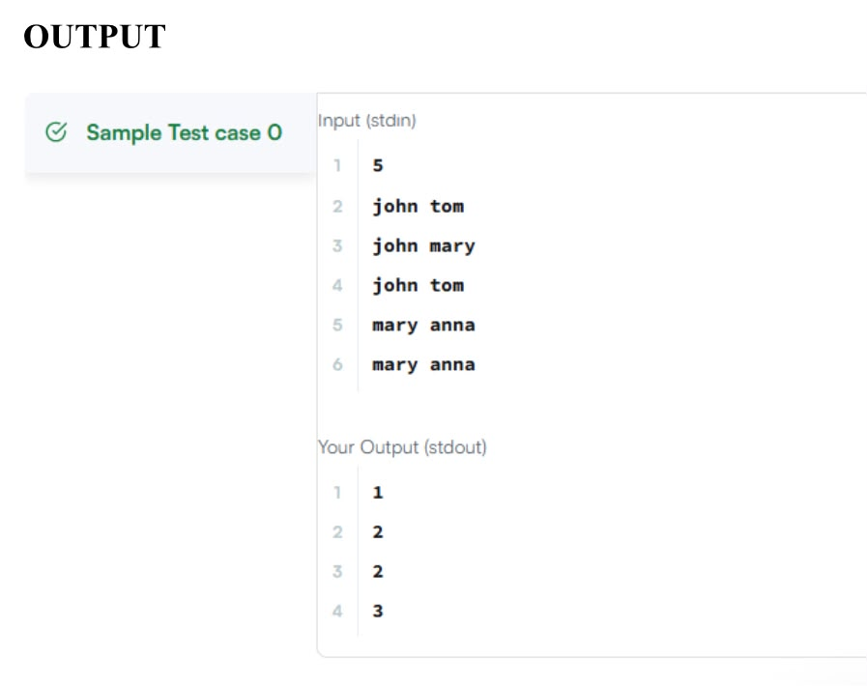

Java Interface
import java.io.*;

// Interface Declared
interface testInterface {

// public, static and final
final int a = 10;

// public and abstract
void display();
}

// Class implementing interface
class TestClass implements testInterface {

// Implementing the capabilities of Interface
public void display(){
System.out.println("Geek");
}
}

class Geeks{

public static void main(String[] args){

TestClass t = new TestClass();
t.display();
System.out.println(t.a);
}
}
Java Iterator 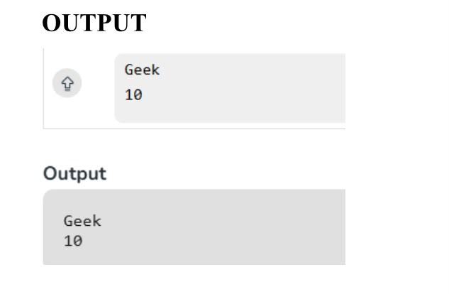

Java Iterator
import java.util.*;
public class Main{

static Iterator func(ArrayList mylist){
Iterator it=mylist.iterator();
while(it.hasNext()){
while(it.hasNext()){
if(it.next().equals("###")){
break;
}
}
break;
}
return it;

}
@SuppressWarnings({ "unchecked" })
public static void main(String []args){
ArrayList mylist = new ArrayList();
Scanner sc = new Scanner(System.in);
int n = sc.nextInt();
int m = sc.nextInt();
for(int i = 0;i<n;i++){
mylist.add(sc.nextInt());
}

mylist.add("###");
for(int i=0;i<m;i++){
mylist.add(sc.next());
}

Iterator it=func(mylist);
while(it.hasNext()){
Object element = it.next();
System.out.println((String)element);
}
}
}
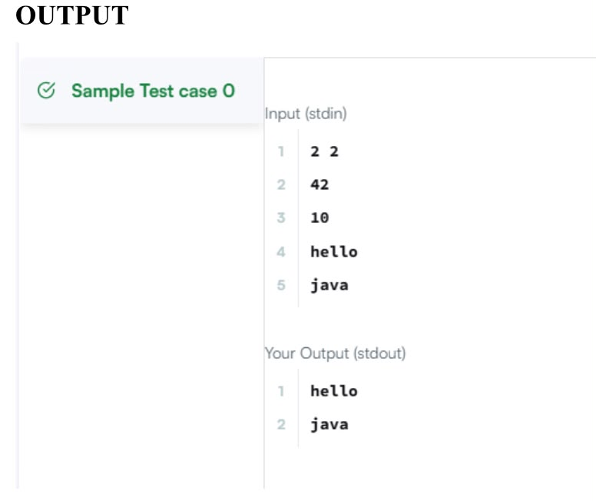

Java Method Overriding 2 (Super Keyword)

import java.util.*;
import java.io.*;

class BiCycle{
String define_me(){
return "a vehicle with pedals.";
}
}

class MotorCycle extends BiCycle{
String define_me(){
return "a cycle with an engine.";
}

MotorCycle(){
System.out.println("Hello I am a motorcycle, I am "+ define_me());
String temp = super.define_me();

System.out.println("My ancestor is a cycle who is "+ temp );
}

}
class Solution{
public static void main(String []args){
MotorCycle M=new MotorCycle();
}
}
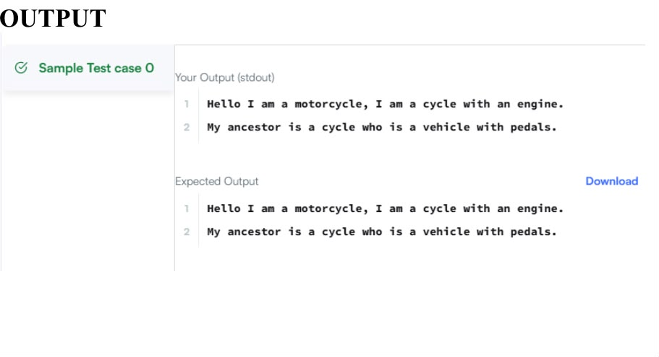
Java Singleton Pattern
import java.io.*;
import java.util.*;
import java.text.*;
import java.math.*;
import java.util.regex.*;
import java.lang.reflect.*;
class Singleton {
private static Singleton single_instance = null;
public String str;
private Singleton() {
}
public static Singleton getSingleInstance() {
if (single_instance == null) {
single_instance = new Singleton();
}
return single_instance;
}
}
public class Main {
public static void main(String args[])throws Exception{
Scanner sc=new Scanner(System.in);
Singleton s1 = Singleton.getSingleInstance(); //retrive the single instance
Singleton s2=Singleton.getSingleInstance();
assert(s1==s2);
//verify that the constructor is private
Class c=s1.getClass();
Constructor[] allConstructors = c.getDeclaredConstructors();
assert allConstructors.length==1;
for (Constructor ctor : allConstructors)
{
if(ctor.getModifiers()!=2 || !ctor.toString().equals("private Singleton()")) //The constructor must be private
{
System.out.println("Wrong class!");
}
}
String str=sc.nextLine();
s1.str=str;
s2.str=str;
System.out.println("Hello I am a singleton! Let me say "+str+" to you");
}
}
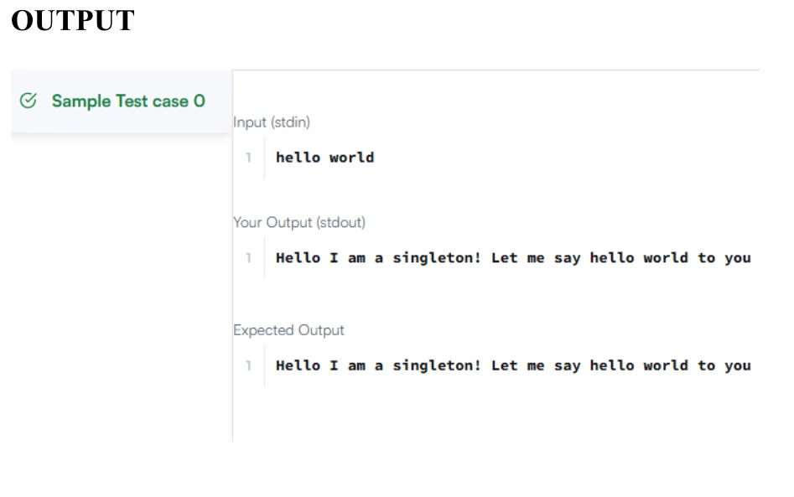
Java Visitor Pattern

import java.io.*;
import java.util.*;

enum Color {
RED, GREEN
}

abstract class TreeVis {
public abstract int getResult();

public abstract void visitNode(TreeNode node);

public abstract void visitLeaf(TreeLeaf leaf);
}

abstract class Tree {
private int value;
private Color color;
private int depth;

public Tree(int value, Color color, int depth) {
this.value = value;
this.color = color;
this.depth = depth;
}

public int getValue() {
return value;
}

public Color getColor() {
return color;
}

public int getDepth() {
return depth;
}

public abstract void accept(TreeVis visitor);
}

class TreeNode extends Tree {
private ArrayList<Tree> children = new ArrayList<>();

public TreeNode(int value, Color color, int depth) {
super(value, color, depth);
}

public void accept(TreeVis visitor) {
visitor.visitNode(this);

for (Tree child : children) {
child.accept(visitor);
}
}

public void addChild(Tree child) {
children.add(child);
}
}

class TreeLeaf extends Tree {
public TreeLeaf(int value, Color color, int depth) {
super(value, color, depth);
}

public void accept(TreeVis visitor) {
visitor.visitLeaf(this);
}
}

class SumInLeavesVisitor extends TreeVis {

private int sum = 0;

public int getResult() {
return sum;
}

public void visitNode(TreeNode node) {
// Nothing required
}

public void visitLeaf(TreeLeaf leaf) {
sum += leaf.getValue();
}
}

class ProductOfRedNodesVisitor extends TreeVis {

private long product = 1;

public int getResult() {
return (int) product;
}

public void visitNode(TreeNode node) {
if (node.getColor() == Color.RED) {
product = (product * node.getValue()) % 1000000007;
}
}

public void visitLeaf(TreeLeaf leaf) {
if (leaf.getColor() == Color.RED) {
product = (product * leaf.getValue()) % 1000000007;
}
}
}

class FancyVisitor extends TreeVis {

private int evenDepthSum = 0;
private int greenLeafSum = 0;

public int getResult() {
return Math.abs(evenDepthSum - greenLeafSum);
}

public void visitNode(TreeNode node) {
if (node.getDepth() % 2 == 0) {
evenDepthSum += node.getValue();
}
}

public void visitLeaf(TreeLeaf leaf) {
if (leaf.getColor() == Color.GREEN) {
greenLeafSum += leaf.getValue();
}
}
}

public class Solution {

public static Tree solve() {

Scanner sc = new Scanner(System.in);

int n = sc.nextInt();

int[] values = new int[n];
for (int i = 0; i < n; i++) {
values[i] = sc.nextInt();
}

int[] colors = new int[n];
for (int i = 0; i < n; i++) {
colors[i] = sc.nextInt();
}

ArrayList<Integer>[] graph = new ArrayList[n];

for (int i = 0; i < n; i++) {
graph[i] = new ArrayList<>();
}

for (int i = 0; i < n - 1; i++) {
int u = sc.nextInt() - 1;
int v = sc.nextInt() - 1;

graph[u].add(v);
graph[v].add(u);
}

return buildTree(
0,
-1,
0,
values,
colors,
graph
);
}

public static Tree buildTree(
int node,
int parent,
int depth,
int[] values,
int[] colors,
ArrayList<Integer>[] graph) {

Color color;

if (colors[node] == 0) {
color = Color.RED;
} else {
color = Color.GREEN;
}

ArrayList<Integer> children = new ArrayList<>();

for (int next : graph[node]) {
if (next != parent) {
children.add(next);
}
}

if (children.size() == 0) {
return new TreeLeaf(values[node], color, depth);
}

TreeNode treeNode = new TreeNode(values[node], color, depth);

for (int child : children) {
treeNode.addChild(
buildTree(
child,
node,
depth + 1,
values,
colors,
graph
)
);
}

return treeNode;
}

public static void main(String[] args) {

Tree root = solve();

SumInLeavesVisitor vis1 = new SumInLeavesVisitor();
ProductOfRedNodesVisitor vis2 = new ProductOfRedNodesVisitor();
FancyVisitor vis3 = new FancyVisitor();

root.accept(vis1);
root.accept(vis2);
root.accept(vis3);

System.out.println(vis1.getResult());
System.out.println(vis2.getResult());
System.out.println(vis3.getResult());
}
}
